SDLC MODELS DOCUMENTATION
Author: Salman Raza
Topic: Agile, Waterfall, V-Model, Spiral

- Waterfall Model
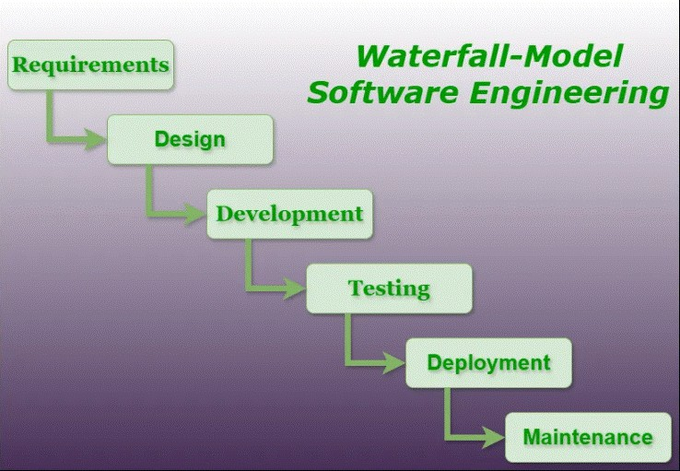

What is Waterfall Model?
Waterfall model is the oldest and simplest SDLC model. Work goes step by step, just like water flows downwards. You can’t go back to a previous step once it is completed. Phases
  - Requirement Gathering – Understand what the customer needs.
  - Design – Decide how the software will look and work.
  - Development – Write the actual code.
  - Testing – Test the software for errors.
  - Deployment – Deliver it to the user.
- Maintenance – Fix issues after release.
When to Use

  - Requirements are fixed.
  - No frequent changes expected.
  - Small projects.
Advantages
  - Very simple and easy to manage.
  - Clear documentation.
Disadvantages
  - No flexibility.
  - Hard to change requirements later.
  - Testing happens very late.

- Agile Model

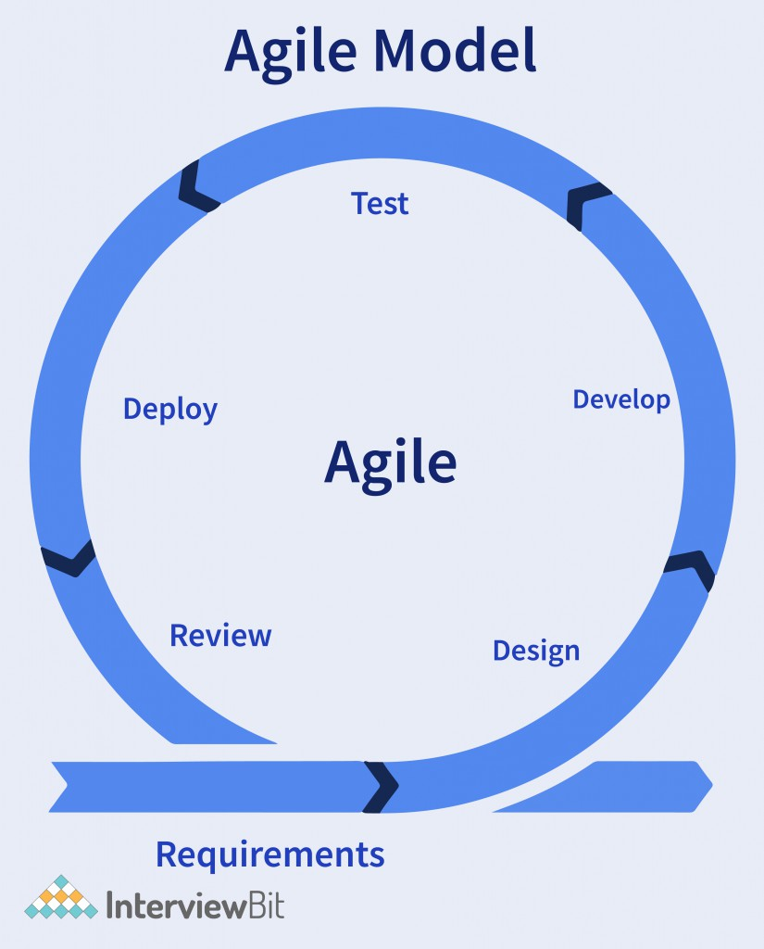

What is Agile Model?
Agile model is flexible and fast.

Work is done in small parts called sprints (usually 1–4 weeks). You can change requirements anytime.
How It Works
- Break the project into small modules.
- Plan → Develop → Test → Review → Repeat.
- Continuous feedback from customer.
When to Use
- Requirements may change.
- Project is large or complex.
- Customer wants quick updates.
Advantages
- Very flexible.
- Faster delivery.
- Better communication with customer.
Disadvantages
- Needs experienced team.
- Documentation is less compared to Waterfall.

- V-Model (Verification & Validation Model)

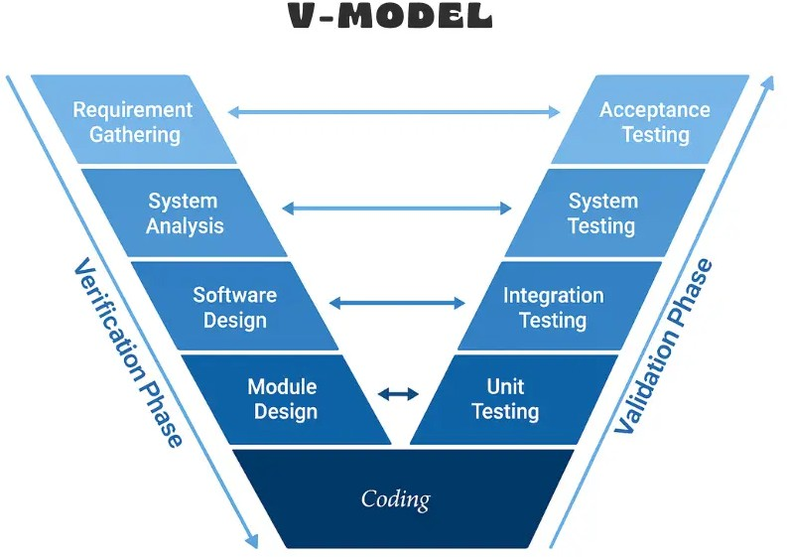

What is V-Model?
- Model is an extension of the Waterfall model.
For every development phase, there is a matching testing phase.

It looks like the letter “V”, which shows mapping of development and testing.
How It Works
Left side = Development Right side = Testing
  - Requirements ↔ Acceptance Testing
  - System Design ↔ System Testing
  - High-Level Design ↔ Integration Testing
  - Low-Level Design ↔ Unit Testing
When to Use
  - Projects where testing is very important.
  - Government, banking, medical projects.
Advantages
  - Testing happens early.
  - Very organized.
Disadvantages
  - Not flexible.
  - Changes are difficult.

- Spiral Model

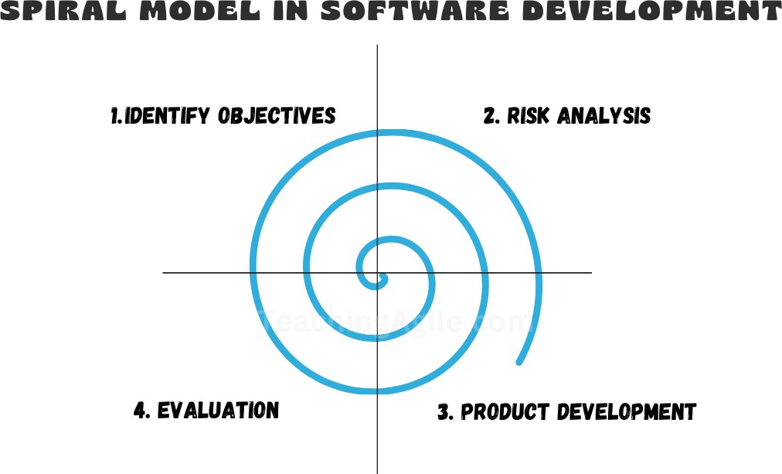

What is Spiral Model?
Spiral model works like a spiral, moving outward. It focuses heavily on risk analysis.

Each loop of the spiral is a phase, and after every loop, the project becomes more complete.
How It Works
Each spiral cycle has four steps:
- Planning
- Risk Analysis
- Development
- Evaluation
When to Use
  - Large and risky projects.
  - When requirements are not clear.
Advantages
  - Best for risk management.
  - Very flexible.
Disadvantages
  - Expensive model.
  - Needs experienced team.

